Installing Anaconda | 
Execute the installer
After the download is finished, the installer will most likely be in your Downloads folder. Double-click the installer file.

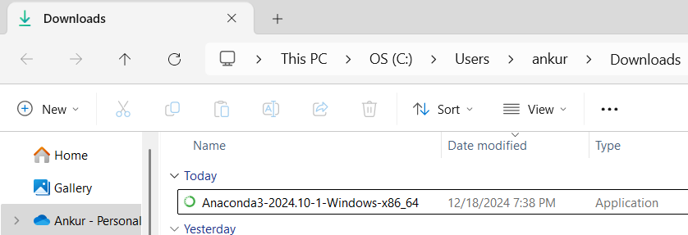

Choose Installation Type
After accepting the terms of the license agreement, you will be prompted to install Anaconda either just for yourself or for all the users. We will go for ‘Just Me’ option.

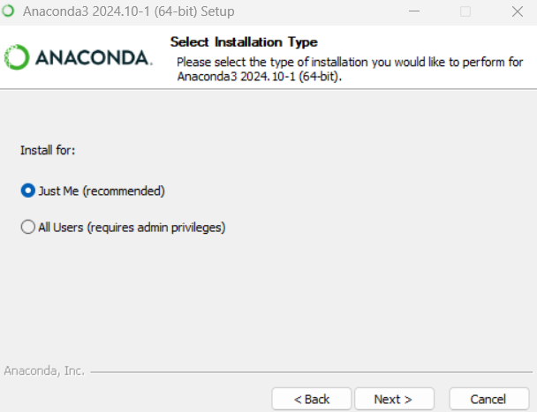

Choose Install Location
Here, you can specify the installation folder. We will go with the default settings and click ‘Next’.

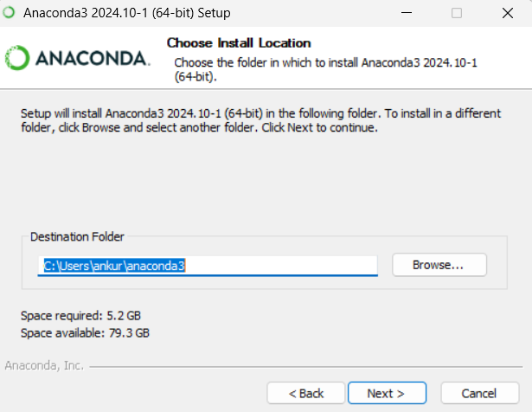

Choose Installation Options
We will again go with the default / recommended settings and click ‘Install’

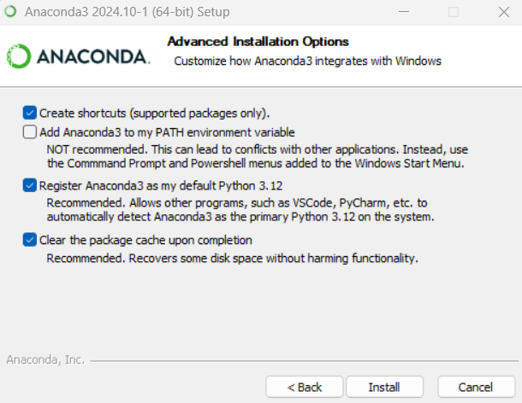

Installation Begins
Installation should proceed without any issues and takes about a few minutes to complete.

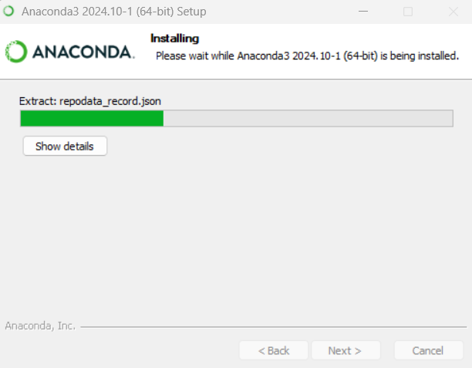

Click ‘Next’ when the installation is complete.

Launch Anaconda Navigator
To see your Anaconda in action, select ‘Launch Anaconda Navigator’ and click ‘Finish’.

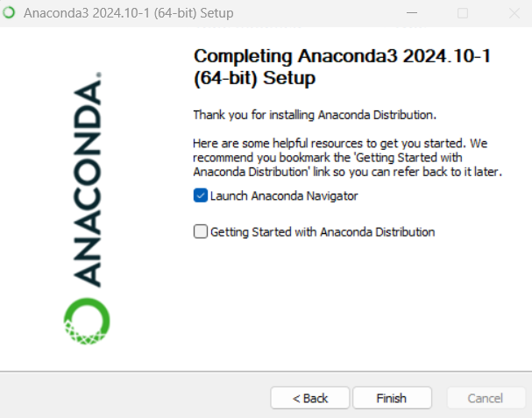

Ta-da! You now have a functioning Python installed on your computer.

